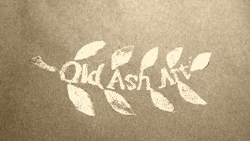

Consent Form to Collect & Use your Personal Information
Please return this completed form to oldashart@outlook.com
Alternatively, post to 12a New Street, Ledbury, Herefordshire, HR82DX.
Under the General Data Protection Regulation (‘GDPR’) there are occasions when Old Ash Art must obtain your explicit consent to use your information, known as ‘Personal Data’. Personal Data includes, but is not limited to your name, address, telephone number and email address.
Old Ash Art would like to hold and use your information for the purposes set out below:
Please tick all relevant boxes to indicate your consent. You may consent to all of the purposes, any number of the purposes or none of the purposes. If you do not consent to Old Ash Art using your information for the purposes listed below then we will not contact you.
To keep me informed of news, services, activities and events relating to Old Ash Art,
To communicate with regards to commissions and post the item to my address.
I consent to Old Ash Art contacting me for the above purpose by:
Post Email Phone SMS Social media
Please complete your details below:
Name:
Address:

Email Address:
Phone Number:
Mobile Number:

Signature:
Date:
Security
We are committed to ensuring that your information is secure. In order to prevent unauthorised access or disclosure, we have put in place suitable physical, electronic and managerial procedures to safeguard and secure the information we collect online.
We will not sell, distribute or lease your personal information to third parties unless we have your permission or are required by law to do so.
You may request details of personal information which we hold about you under the Data Protection Act 1998. If you would like a copy of the information held on you please contact Old Ash Art.
If you believe that any information we are holding on you is incorrect or incomplete, please write to or email us as soon as possible, at the above address. We will promptly correct any information found to be incorrect.
You can change your consent preferences or withdraw your consent completely by contacting Rachel Drury, Old Ash Art. The use of your information will cease immediately.
Thank you for your patience.

